1-05 The Scope Statement
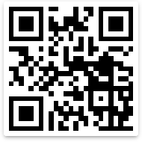
https://youtu.be/weWn6Lf8AjQ

1-07 The Widget Company Management Commitment
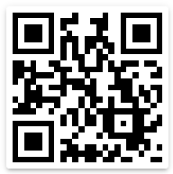
https://youtu.be/weWn6Lf8AjQ

2-02 Risks and Opportunities
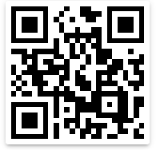
https://youtu.be/L4xCCYpFZcY

2-07 Organizational Knowledge Fail Part 1
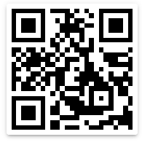
https://youtu.be/WmFL4NFBeTY

Part 2-07 Organizational Knowledge Fail Part 2
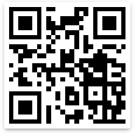
https://youtu.be/QtnYFADVN_c

2-07 Organizational Knowledge Fail Part 3
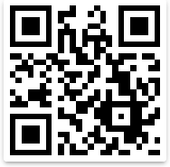
https://youtu.be/BYBeHSH1ksA

2-08 Lessons from Dog Training Part 1
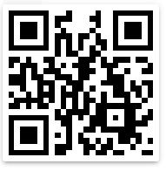

Lessons from Dog Training (Part 2)
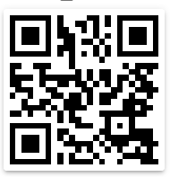
https://youtu.be/CRsRz3J3tds

2-10 The Widget Company Document Control
https://youtu.be/jUv8cS8LWVA

3-06 The Widget Company Design Fail Part 1
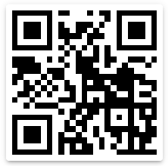
https://youtu.be/LHKK3t-t1e8

3-06 The Widget Company Design Fail Part 2
https://youtu.be/LHKK3t-t1e8

3-06 The Widget Company Design Fail Part 3
https://youtu.be/LHKK3t-t1e8

3-07 Widget Company Purchasing Fail
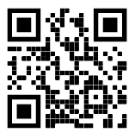
https://youtu.be/2847QHRu2Lc

3-10 Change Control Fail Top Gun Pilots
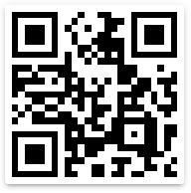
https://youtu.be/NMHjAlgMnj0

3-10 Product Release Fail—Why your Car Got Recalled

https://youtu.be/e_Ag2nwGsn8

3-11 How to Kill a Famous Company
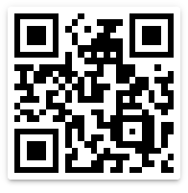
https://youtu.be/TMedtZoo7FU

Clause | Documented Information
4.3 | Scope Statement
4.4.2 | Support the Operation of the Processes
4.4.2 | Have confidence that the processes are being carried out as planned
5.2.2 | Quality Policy
6.2.1 | Quality Objectives
7.1.5.1 | Fitness for purpose of the monitoring and measurement resources
7.1.5.2 | Basis for calibration or verification
7.2 | Evidence of competence
7.5 | Documented information required by the international standard
7.5.2 | Documented information determined to be necessary for effectiveness of the QMS
7.5.3 | Controlled Records
8.2.3.2 | Results of the contract review
8.2.3.2 | New Requirements for the Products and Services
8.4.2.4 | Changes in requirements for products and services
8.3.2 | Evidence that design and development requirements have been met

8.3.3 | Design and development inputs
8.3.4 | Design and development controls
8.3.5 | Design and development outputs
8.3.6 | Design and development changes
8.3.6 | Results of the design review
8.3.6 | Authorization of Design Changes
8.3.6 | Actions taken to prevent adverse impacts
8.4.1 | Supplier Evaluations and Necessary Actions
8.5.1 | Document that defines the characteristics of the product or service
8.5.1 | Results to be Achieved
8.5.2 | Traceability Documents
8.5.3 | Damaged or missing externally owned property
8.5.6 | Review of production or service changes
8.6 | Evidence of conformity (Test Results)
8.6 | Traceability of persons authorizing product release
8.7.2 | Description of Nonconformity
8.7.2 | Actions Taken vs. Nonconformity
8.7.2 | Concessions obtained for nonconformity
8.7.2 | ID of authority deciding action on Non Conformity
9.1.1 | Monitoring and Measuring Results
9.3.3 | Results of Management Review
10.2.1 | Nature of a Nonconformity and subsequent actions taken
10.2.1 | Results of any corrective action

